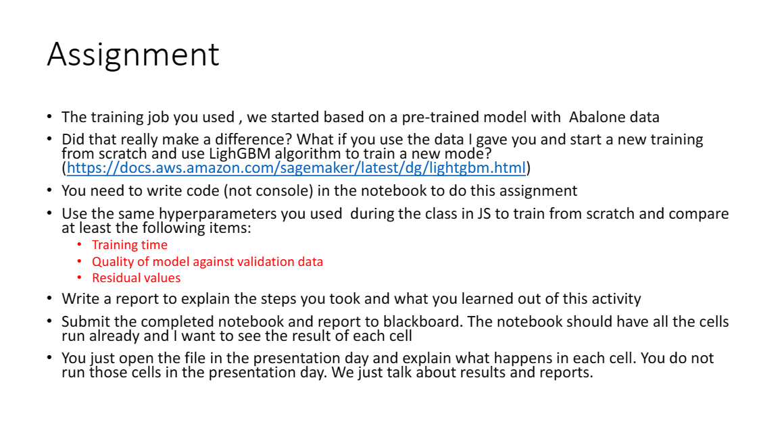

Comparison

After using the same hyper parameters and re-running a training from scratch by using LightGBM algorithm, it was seen that the both pretrained model and the model trained on notebook takes approximately same time. The pretrained model takes equivalent to 2 minutes as shown below –

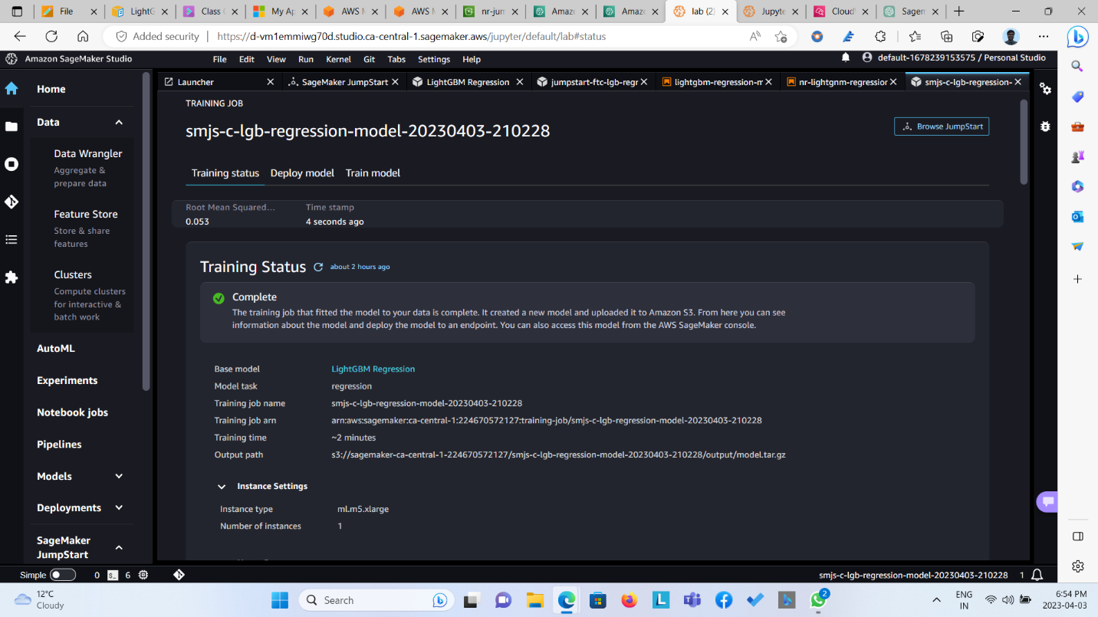

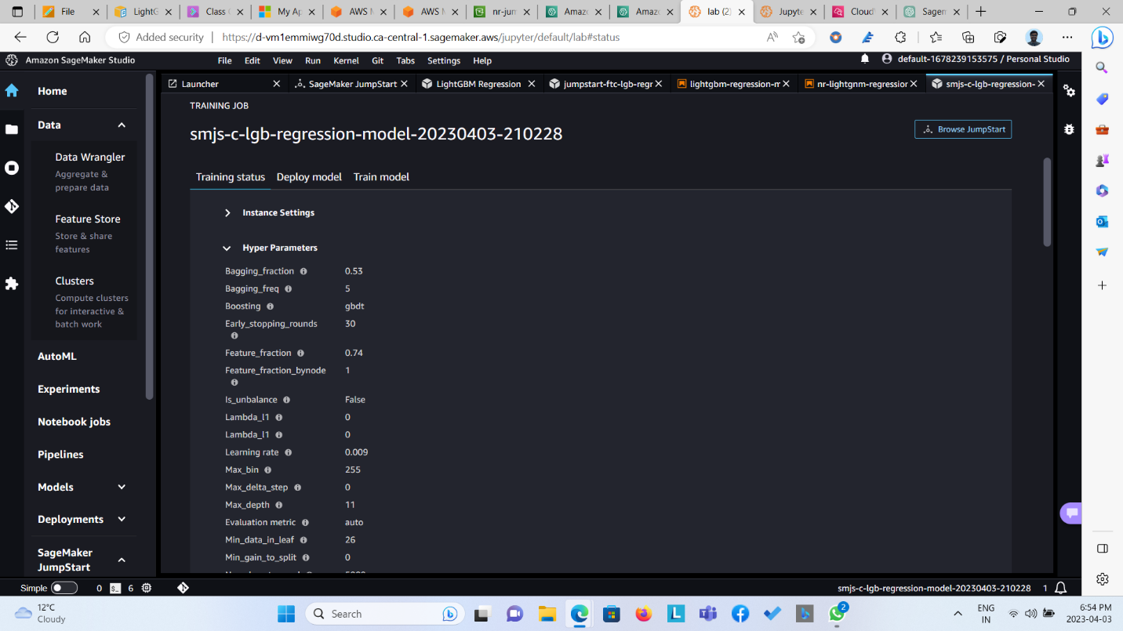

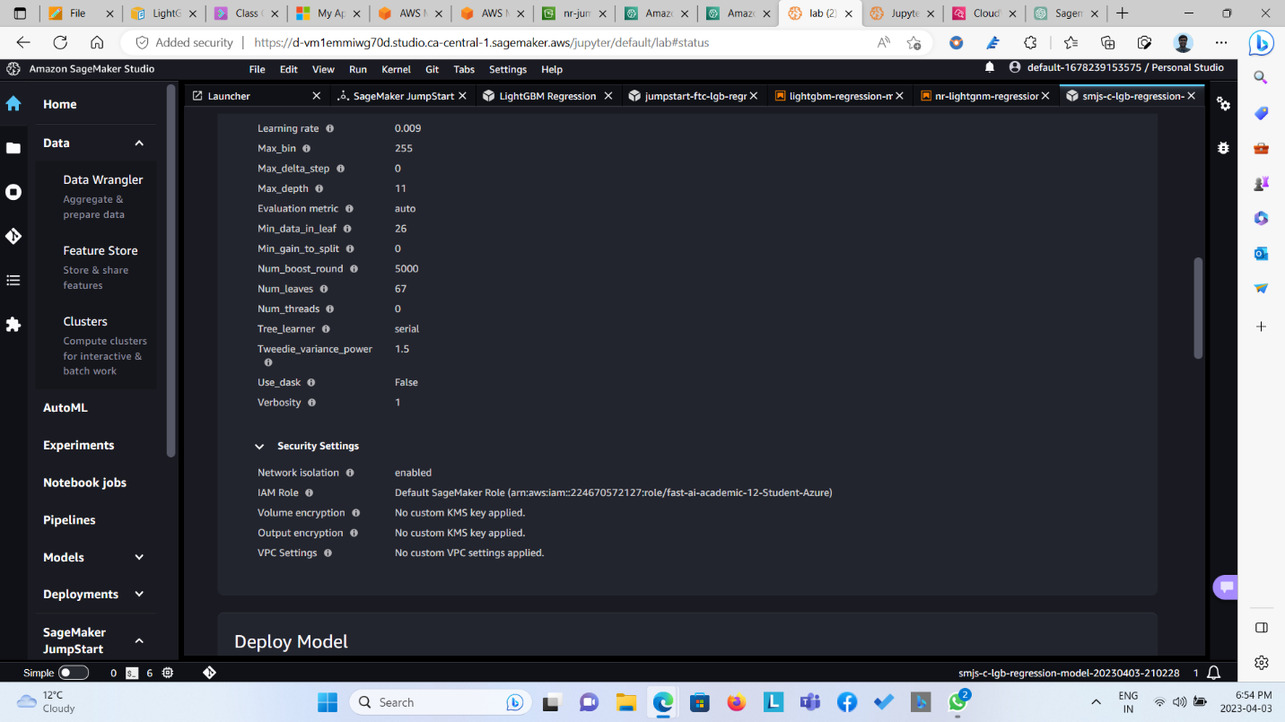

Whereas the model trained on notebook also takes nearly 101 training seconds which is equivalent to 2 minutes.

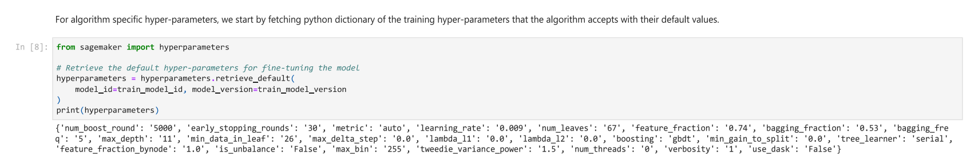

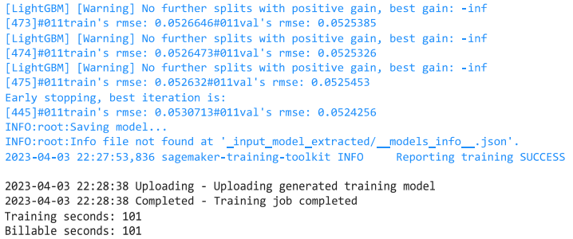

When we compare with the quality of model with respect to the validation data as well as with the residual values, it is noticed that with pretrained model, the best training rmse value is 0.0530 and best validation rmse is 0.0524. The pretrained model’s R2 Score is 0.83478, mean squared error is 0.00327 and mean absolute error is 0.04144, which is as shown below.

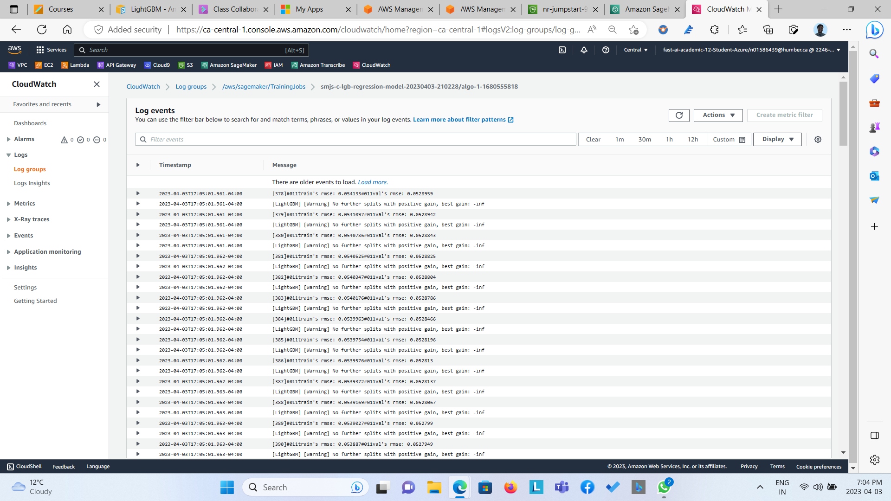  
  
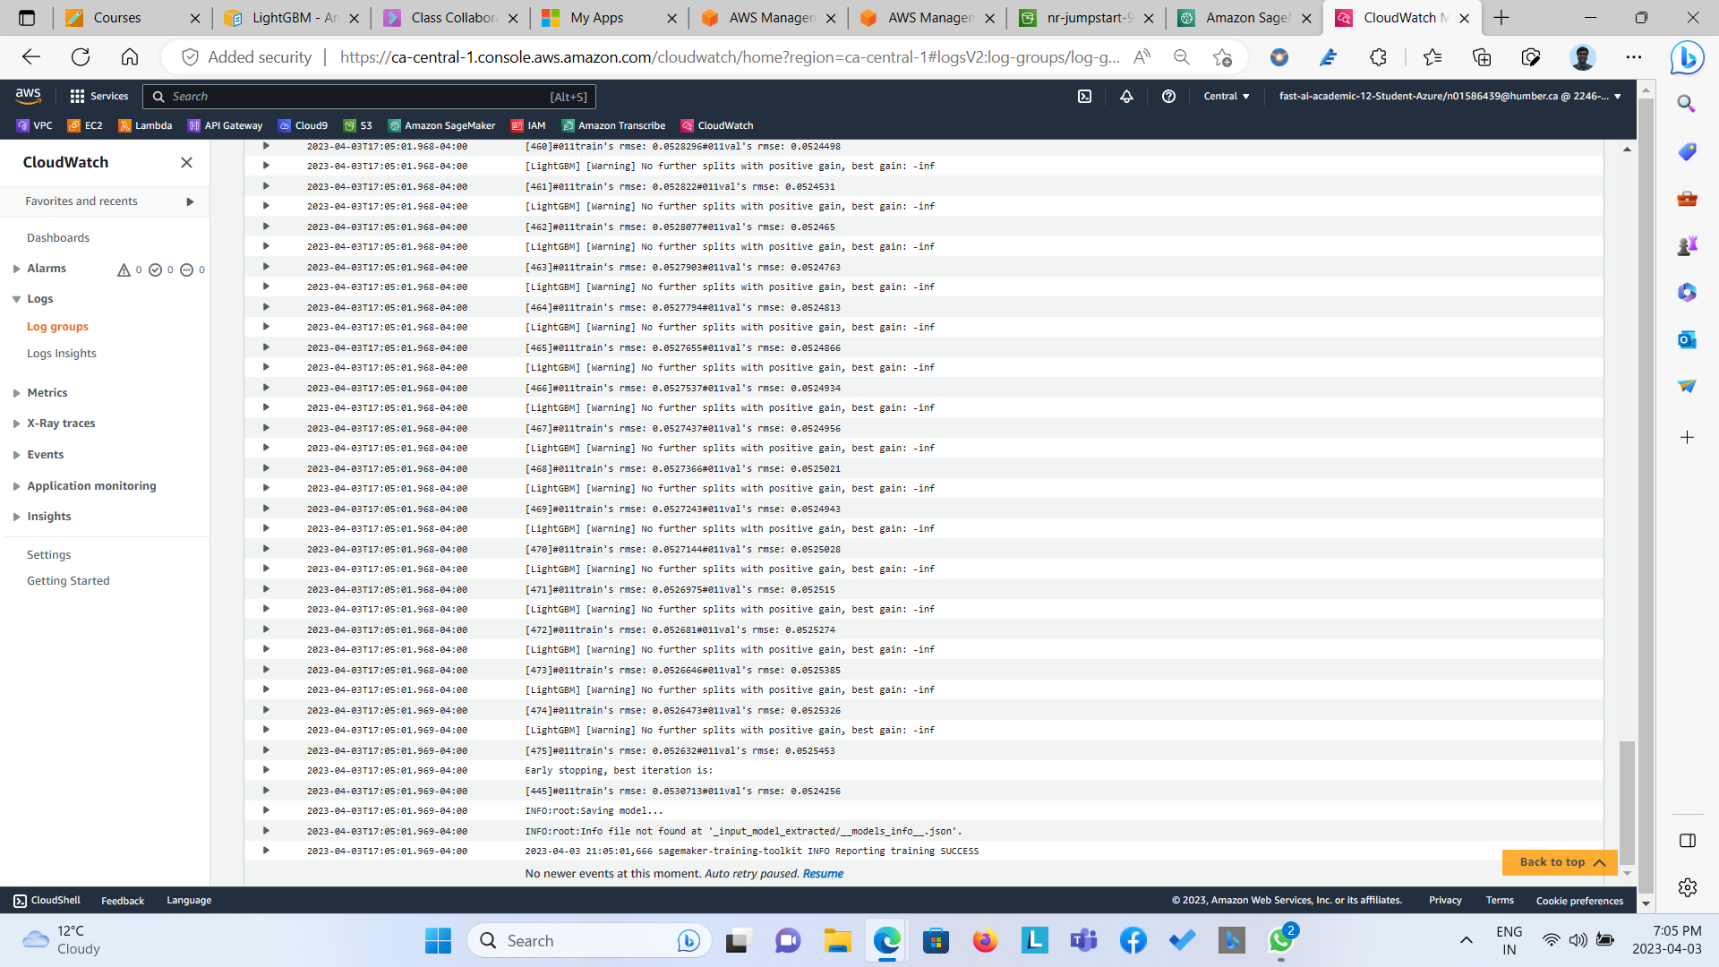

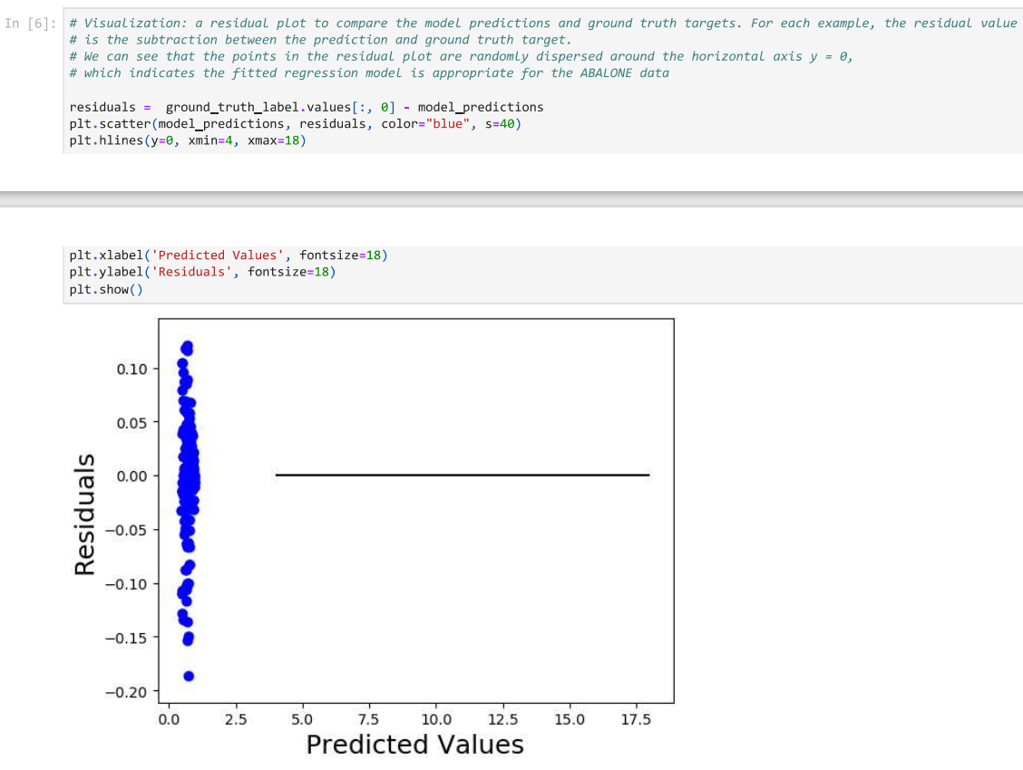

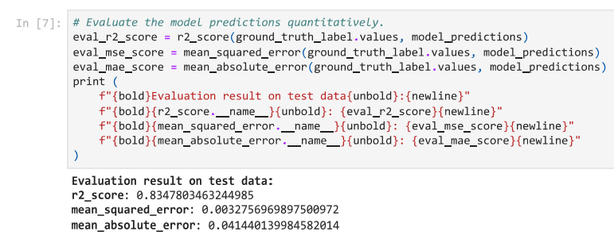

When we compare with the quality of model with respect to the validation data as well as with the residual values, it is noticed that with model trained on notebook gives identical values with respect to pretrained model. The best training rmse value is 0.05307 and best validation rmse is 0.05242. The pretrained model’s R2 Score is 0.83478, mean squared error is 0.00327 and mean absolute error is 0.04144, which is as shown below.

